MACONDO WRITERS WORKSHOP 2025
JULY 21–JULY 27, 2025 AT TRINITY UNIVERSITY, SAN ANTONIO, TX
The Macondo Writers Workshop is an association of socially-engaged writers working to advance creativity, foster generosity, and serve the community. Founded in 1995 by writer Sandra Cisneros and named after the town in Gabriel García Marquez’s One Hundred Years of Solitude, the workshop gathers writers from all genres who work on geographic, cultural, economic, gender, and spiritual borders. An essential aspect of the Workshop is a global sense of community; participants recognize their place as writers in our society and the world. We are also seasoned writers who demonstrate a professional or master’s level of writing. Qualified applicants must meet both criteria. Excellent writing does not excuse poor community spirit; vice-versa, an impressive record of community involvement does not excuse poor writing. Macondo is a gift we give to one another, with willing hands and open hearts.
WHEN: JULY 21 THROUGH JULY 27, 2025
WHERE: TRINITY UNIVERSITY, SAN ANTONIO, TEXAS
COSTS:
- $830 FOR WORKSHOP CLASSES
- $350 FOR CHUPAROSAS
- $667 FOR SINGLE OCCUPANCY ROOM & BOARD (Shared Bathroom), INCLUDES: BREAKFAST & LUNCH, LINENS & FACILITIES
- $546 FOR DOUBLE OCCUPANCY ROOM & BOARD (Shared Bathroom), INCLUDES: BREAKFAST & LUNCH, LINENS & FACILITIES
- EARLY SUNDAY ARRIVAL CAN BE ADDED FOR AN ADDITIONAL $35.
- $270 COMMUTER PASSES ARE REQUIRED FOR PARTICIPANTS STAYING OFF-CAMPUS
- PARTICIPANTS ARE RESPONSIBLE FOR COVERING THE COST OF THEIR OWN TRANSPORTATION, DINNERS, AND INCIDENTALS

THE APPLICATION DEADLINE IS FEBRUARY 23, 2025 (11:59 PM PACIFIC TIME). IN ORDER FOR AN APPLICATION TO BE CONSIDERED COMPLETE, A $35 APPLICATION FEE MUST BE PAID ONLINE HERE OR BY MAILED CHECK TO DR. NORMA E. CANTÙ, TRINITY UNIVERSITY–NORTHRUP HALL 244, ONE TRINITY PLACE, SAN ANTONIO, TX 78212, POSTMARKED BY FEBRUARY 23, 2025.
THE APPLICATION MUST BE SUBMITTED TO MACONDOAPPLICATION@GMAIL.COM
ACCEPTED PARTICIPANTS WILL BE NOTIFIED NO LATER THAN MARCH 31, 2025 AND SCHOLARSHIP APPLICATIONS WILL BE MADE AVAILABLE TO ACCEPTED PARTICIPANTS.
THE WORKSHOP
The Macondo Writers Workshop is a master’s level workshop, meaning that participants are expected to be established writers capable of reviewing each other’s work with compassionate rigor and vision. In 2025 we will hold four in-person workshops, which meet for four days, three hours daily. We will have multi-genre, poetry, fiction and nonfiction workshops. The number of participants in each workshop is not expected to exceed ten people. Macondo will officially end on Sunday morning on July 27, 2025.
In addition to the workshops, seminars give Macondistas a chance to discuss a wide range of topics related to the arts, politics, publishing, and the life of a writer. Events planned throughout the week provide opportunities for Macondistas to visit, get to know each other and exchange ideas. We offer morning yoga and evening hangouts. We also host faculty readings and participant readings, which we share with the larger community.
Trinity University will provide the physical space to Macondo participants. We are grateful to University President, Dr. Vanessa Beasley and her wonderful faculty/staff for their commitment to ensuring a successful Macondo Writers Workshop.
The Macondo Writers Workshop is a self-sustaining organization. As such, the Macondo Writers Workshop gladly accepts financial contributions as well as in-kind donations to assist with the production of the workshop and for scholarships. Please go to our website www.MacondoWriters.com, and click on the “Donate” button.
We’d greatly appreciate your help in spreading the word about our open applications. Please share with fellow writers, your networks, listservs, and any relevant communities.

2025 FACULTY
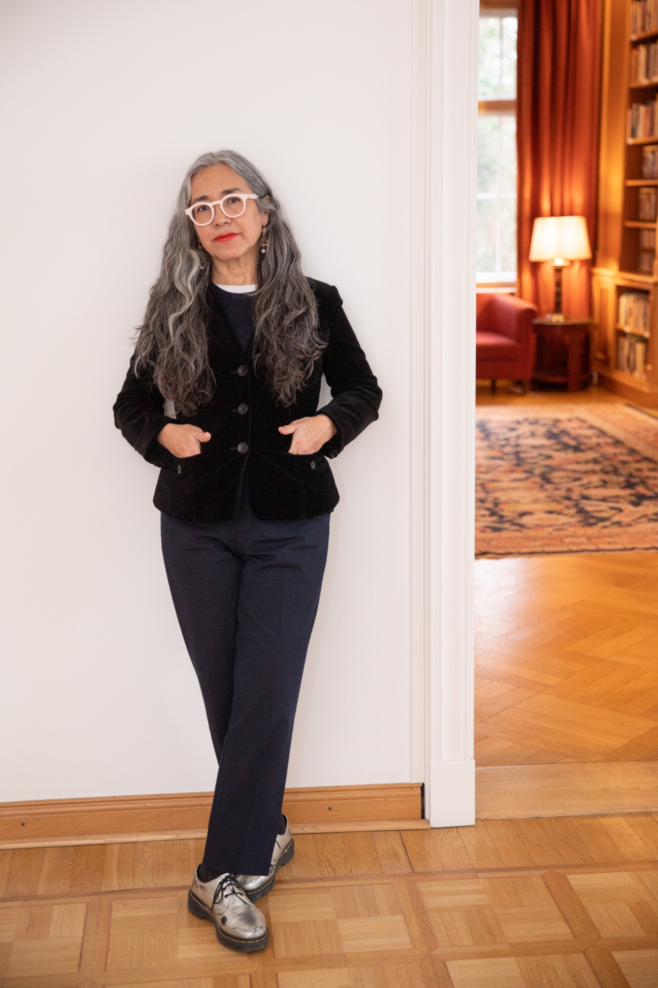 | 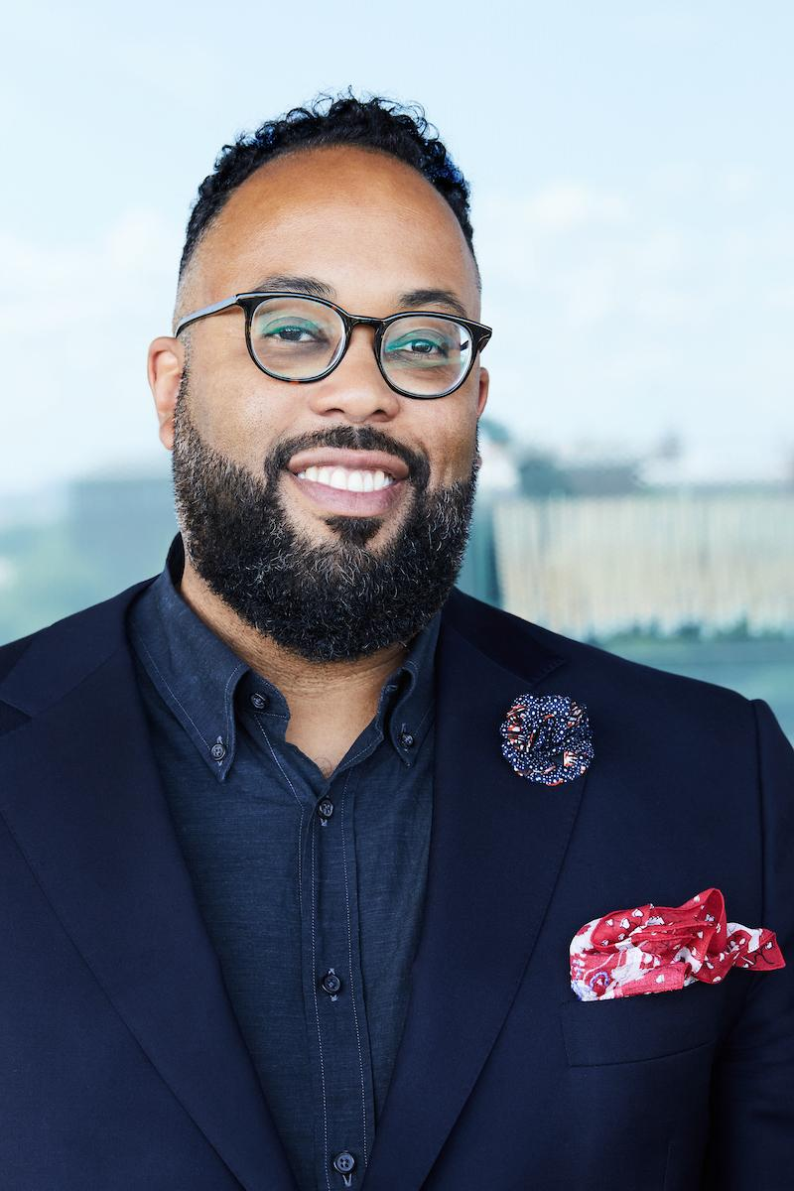 | 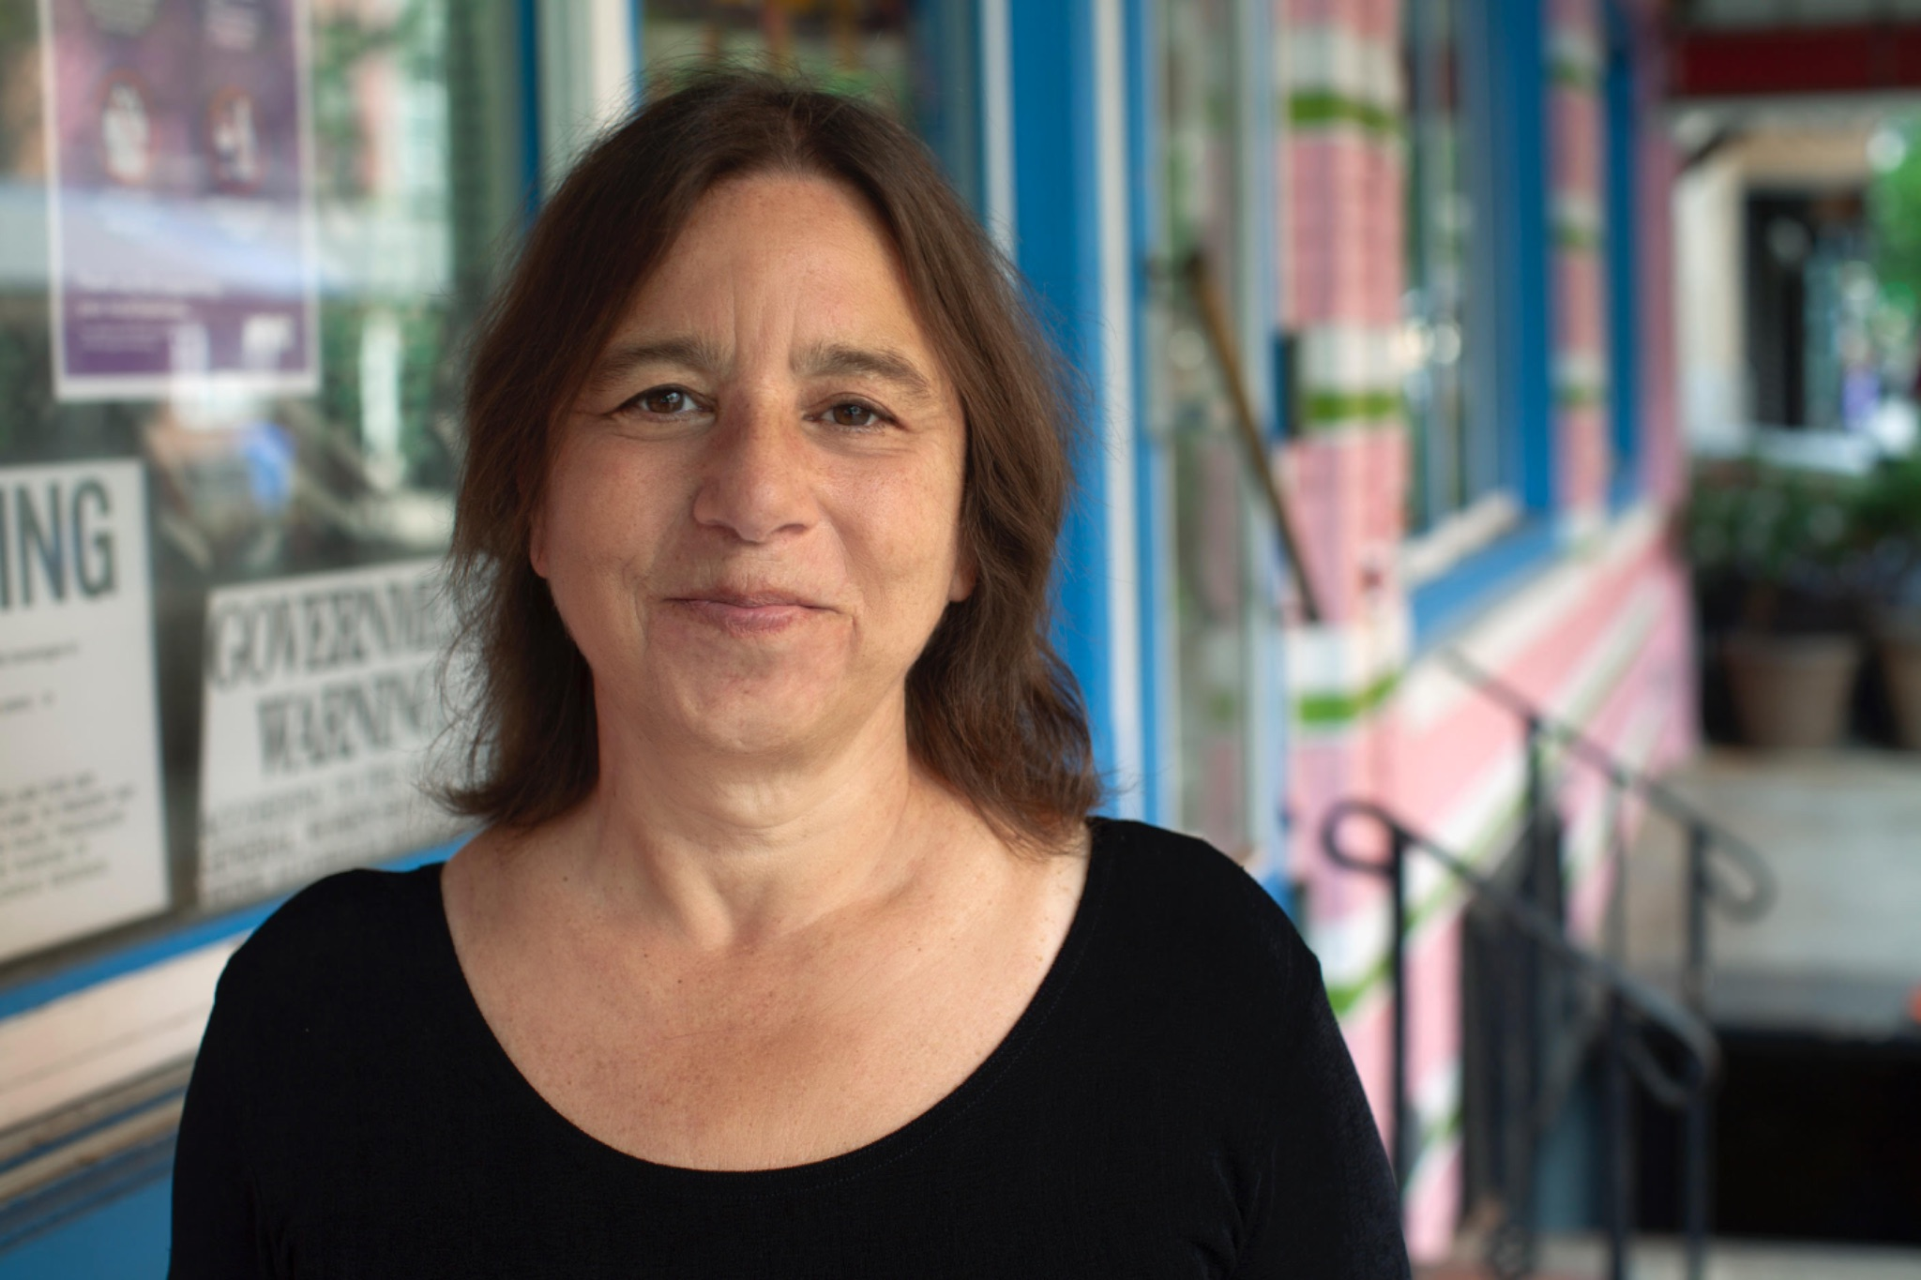 | 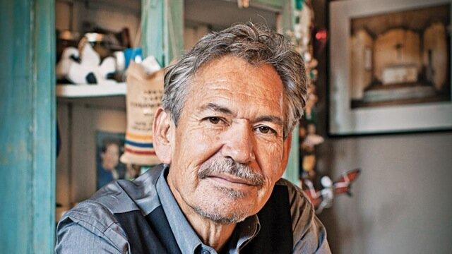
Cristina Rivera Garza  Multi-Genre | Kevin Young  Poetry | Sarah Schulman  Nonfiction | Benjamin Alire Sáenz  Fiction

2025 WORKSHOPS
MULTI-GENRE
Cristina Rivera Garza

Jardines Planetarios Bajo Los Rayos Políticos Del Sol / Planetary Gardens Under The Political Light Of The Sun: A Molecular Workshop on Description, Sentence-Making, and Tone

During our workshop-seminar we will explore the intricate relationship between writing and plants, situating them within the context of our increasingly threatened solar system. Through in-depth readings of both theoretical and creative works, we will delve into the process of crafting descriptions, sentences, and tone while also (hopefully) engaging in the tending of our own planetary garden in the areas surrounding our position on earth.

The “plantness” of plants poses unique challenges to our writing, especially when some of them are errant beings forging gardens many would describe as invasive. In addition to reading together and out loud, we will engage in situ writing exercises of varying lengths directly connected to dates outlined in our syllabus and in alignment to the development of our planetary garden. Following each writing exercise, we will come together for conversations about the process and the writing that emerges from them. We will devote three sessions to formal workshop writings specifically focusing on description, sentence-making, and tone, which will require you to write creative writing exercises in advance of dates in the syllabus.

Cristina Rivera Garza is the award-winning author of The Taiga Syndrome and The Iliac Crest, among many other books. Her memoir Liliana’s Invincible Summer won the Pulitzer Prize and was a finalist for the National Book Award. A recipient of the MacArthur Fellowship and the Sor Juana Inés de la Cruz Prize, Rivera Garza is the M. D. Anderson Distinguished Professor in Hispanic Studies, and director of the Ph.D. program in creative writing in Spanish at the University of Houston.
LETRAS LATINAS IS A COLLABORATOR AND SPONSOR OF THE MULTI-GENRE WORKSHOP

POETRY
Kevin Young
Deep Song
In this in-depth workshop, through looking at your book- or chapbook-length manuscripts and series, we will delve into the aspects of what makes a book sing, from cohesion to connection, variety to clarity. We will discuss large-scale aspects of craft, with a focus on the jazz-like process of improvisation and revision. Workshop participants will emerge with a fresh sense of their work’s deep structures and future possibilities
Kevin Young is the Andrew W. Mellon Director of the Smithsonian’s National Museum of African American History and Culture. He previously served as the director of the Schomburg Center for Research in Black Culture. Young is the author of fifteen books of poetry and prose, including Stones, shortlisted for the T.S. Eliot Prize; Brown; Blue Laws: Selected & Uncollected Poems 1995-2015, longlisted for the National Book Award; Book of Hours, winner of the Lenore Marshall Prize from the Academy of American Poets; Jelly Roll: a blues, a finalist for both the National Book Award and the Los Angeles Times Book Prize for Poetry; Bunk a New York Times Notable Book, longlisted for the National Book Award and named on many “best of” lists for 2017; and The Grey Album, winner of the Graywolf Press Nonfiction Prize and the PEN Open Book Award, a New York Times Notable Book, and a finalist for the National Book Critics Circle Award for criticism. The poetry editor of the New Yorker, where he hosts the Poetry Podcast, Young is the editor of ten other volumes, including A Century of Poetry in the New Yorker, 1925-2025 (Knopf, February 2025) and the acclaimed anthology African American Poetry: 250 Years of Struggle & Song. He is a member of the American Academy of Arts and Sciences, the American Academy of Arts and Letters, the Society of American Historians, and was named a Chancellor of the Academy of American Poets in 2020.

NONFICTION Sarah Schulman
From Expression to Communication
Starting a new piece is creating raw material, in the way that a potter makes their clay. By renewing our experiences of craft, we can transform those impulses and expressive bursts into something that will be meaningful to the reader. And throughout, we will be in collective conversation about what it means to grapple with content that matters, while engaging form that comes organically from the emotions at the core of the piece.
Sarah Schulman is a novelist, playwright, screenwriter, nonfiction writer, and AIDS historian. Her 21 books include the novels The Cosmopolitans, Maggie Terry, Rat Bohemia, Shimmer, After Delores and the nonfiction books Gentrification of the Mind, Conflict is Not Abuse, Israel/Palestine and the Queer International, Let The Record Show: A Political History of ACT UP, New York 1987-1993 and forthcoming in 2025, The Fantasy and Necessity of Solidarity. Her honors include a Guggenheim in Playwriting, a Fulbright in Judaic Studies, Lambda Literary Book Award, Lifetime Achievement Awards from The Publishing Triangle and The City University of New York Kessler Prize for Contribution to LGBT Studies. Her work has appeared in the New Yorker, New York Magazine, Harpers, The Atlantic, The New Republic, The Nation, The New York Times, the Guardian of London and more. Sarah holds an endowed chair in Creative Writing at Northwestern University and is on the Advisory Board of Jewish Voice for Peace.
FICTION Benjamin Alire Sáenz
Writing Comes from The Writer: Nowhere to Hide. Why Who You Are Matters So Much in the Fiction You Write
This is a generative workshop whose focus will be on writing honestly in the most profound understanding of that word. In this workshop we are going to listen to what we are doing. We must be vulnerable on the page with intent. I don’t believe that writing that is emotionally anorexic is compelling. At the other extreme, writing that suffers from emotional exhibitionism is dull and self-centered. Writing must be emotionally true and a writer has to learn to be vulnerable. Writing isn’t about exhibiting our intelligence—it’s about sharing our humanity with the reader. Which means that our writing expresses our emotional intelligence and our compassion. What makes a writer a writer. Certainly knowing your craft is a must. But merely knowing the elements of a story won’t make anyone a writer. What makes a writer a writer is her ability to deeply connect with herself and to deeply connect with others. A writer who lacks compassion for other human beings will never write anything that matters. There is always a riot in the heart. We are all fighting our own private wars. It is the work of the writer to know himself and embrace his own weaknesses and failings. A writer is able to speak of human flaws because he understands his own flaws. If a writer is a healer, then she is a wounded healer. In our writing we must abandon all fear and go to the place of the pain. To communicate that in ones writing is what makes a writer a writer. You must not only listen to the rhythm of the human heart but you must also listen to the rhythms of the language you are writing in. You must be careful and disciplined and be spontaneous all at once. If you are truly alive, then your writing will be truly alive as well.

Benjamin Alire Sáenz is an award-winning American poet, novelist and writer of children’s books. He was born at Old Picacho, New Mexico, the fourth of seven children, and was raised on a small farm near Mesilla, New Mexico. He graduated from Las Cruces High School in 1972. That fall, he entered St. Thomas Seminary in Denver, Colorado where he received a B.A. degree in Humanities and Philosophy in 1977. He studied Theology at the University of Louvain in Leuven, Belgium from 1977 to 1981. He was a priest for a few years in El Paso, Texas before leaving the order.

In 1985, he returned to school, and studied English and Creative Writing at the University of Texas at El Paso where he earned an M.A. degree in Creative Writing. He then spent a year at the University of Iowa as a PhD student in American Literature. A year later, he was awarded a Wallace E. Stegner fellowship. While at Stanford University under the guidance of Denise Levertov, he completed his first book of poems, Calendar of Dust, which won an American Book Award in 1992. He entered the Ph.D. program at Stanford and continued his studies for two more years. Before completing his Ph.D., he moved back to the border and began teaching at the University of Texas at El Paso in the bilingual MFA program.

His first novel, Carry Me Like Water was a saga that brought together the Victorian novel and the Latin American tradition of magic realism and received much critical attention.

In The Book of What Remains (Copper Canyon Press, 2010), his fifth book of poems, he writes to the core truth of life’s ever-shifting memories. Set along the Mexican border, the contrast between the desert’s austere beauty and the brutality of border politics mirrors humanity’s capacity for both generosity and cruelty.

In 2005, he curated a show of photographs by Julian Cardona.

He lives and works in El Paso, Texas.

CHUPAROSAS
Open to Returning Macondistas Only
Chuparosas will be expected to work on a current writing project independently. They will be able to participate in the week of activities during the Macondo Writers Workshop -- attend the morning yoga, seminars, and readings. Macondo provides a designated room for Chuparosas to write-alone-together during the scheduled workshop time from 1- 4 p.m. (CST) and two Macondista volunteer-leaders help coordinate that experience. All Chuparosas are encouraged to form small writing groups and find community during Macondo 2025

2025 MACONDO WRITERS WORKSHOP APPLICATION
Instructions
- Complete all sections of the application, including essay questions. At this time, we require that applications, including the essay response, be submitted in English. NOTE: Returning Macondistas are only required to (1) fill out contact information, (2) identify the workshop to which they are applying, (3) if applicable, include any previous contributions to Macondo: (served on reading panels, seminars, etc.)
- Attach or cut and paste a 10-page writing sample at the end of the application. We can only accept writing samples in English. Use 1” margins, 12 pt font Times New Roman (or similar). Your writing sample should reflect the genre you are applying to.
- Save this application as a .doc or .docx (No PDFs Accepted) using the following format: Last name.application.docx (e.g. Gonzalez.application.docx)
- Send your application as an attachment to macondoapplication@gmail.com by February 23, 2025 (11:59pm Pacific Time). Applications that are late or incomplete will not be reviewed. Submitted materials, including applications, essays, and writing samples, are evaluated through a blind-review process by a rotating committee of past Macondo Workshop participants. Applicants will be notified of the committee’s decision no later than March 31, 2025. Participants will be announced and considered accepted once we receive the signed Participant Agreement, no later than April 6, 2025.
- Letters of recommendation or nominations are neither required nor accepted.
- Scholarship Information: There are no waivers to cover the workshop application and processing fee. A limited amount of partial scholarships will be available to accepted participants, with preference for first-time Macondistas.

NOTE: A nonrefundable, nontransferable $35.00 application and processing fee is due with the application. That is paid through a Trinity University payment portal https://web.cvent.com/event/ab0fdca8-0f03-4468-a9ac-f39bc2f40c20/. This link is also available on the macondowriters.com website.

The application itself must be submitted to
Macondoapplication@gmail.com

I. Contact Information
Name:
Address:
City, State, Zip:
Phone:
Email:

WORKSHOP YOU ARE APPLYING TO
Check ONE box only, multiple choices will disqualify the application:
( ) MULTI-GENRE WORKSHOP with CRISTINA GARZA RIVERA
( ) POETRY WORKSHOP with KEVIN YOUNG
( ) NONFICTION WORKSHOP with SARAH SCHULMAN
( ) FICTION WORKSHOP with BENJAMIN ALIRE SÁENZ
( ) CHUPAROSAS Please see item below
RETURNING MACONDISTAS, PLEASE INCLUDE ANY SERVICE TO MACONDO THAT YOU MAY HAVE PREVIOUSLY CONTRIBUTED, (E.G. SERVED ON READING PANELS, SEMINARS, ETC.) PREVIOUS SERVICE CAN BE CONSIDERED IN CONTEXT OF ALLOTING RETURNING MEMBER SPACES FOR HIGH-DEMAND WORKSHOPS.
- __________________________________________________________________________________________________________________________________________________________________________________________________________________________________________________________________

II. Requirements
NOTE: Returning Macondistas, please enter the year you last attended Macondo here _____ and skip the remainder of the application.

New Applicants must fulfill at least TWO of the following. Please check all that apply:

( ) I have published one or more books of poetry, fiction, non-fiction, or creative non-fiction. List title(s), publisher, publication date, and genre:

- _____________________________________________________________
( ) I have completed a book-length manuscript of poetry, fiction, non-fiction, or creative non-fiction. List title(s), page length(s), and genre(s):
- _____________________________________________________________
- _____________________________________________________________

( ) I have published at least three poems, stories, works of non-fiction or creative non-fiction in journals or magazines. List titles, publication, and publication date:
- _____________________________________________________________
- _____________________________________________________________
- _____________________________________________________________
( ) I have been enrolled in or have completed an MFA writing program. List institution(s) and dates:
- _____________________________________________________________
- _____________________________________________________________
( ) I have studied under at least three writers. List names, inclusive dates and places of study:
- _____________________________________________________________
- _____________________________________________________________
- _____________________________________________________________

III. Short Essay Question
The Macondo Workshop is united by a dedication to community service and a belief that writing can affect nonviolent social change. Please respond to this statement in the context of your writing, your community service, your personal history, and/or other achievements and experiences you think relevant (500 to 800 words).

IV. Writing Sample
Please attach or paste a 10-page maximum/8-page minimum writing sample below. Your writing sample should be either Multi-Genre, Poetry, Fiction, or Nonfiction in accordance with your workshop preference.
Submission manuscript must be typed, double-spaced, and in Times New Roman (or similar), 12 pt. font, 1” margins (.5 header/footer), .doc or .docx (No PDFs Accepted)
On the first page of the manuscript, applicants must provide the following:
- Top left side of page: Indicate application program (Faculty name and Genre)
- Top right side of page: Your name. (Please use your actual name, not the name you write under.)
ATTACH WRITING SAMPLE ⬇

